Practical R Activity Eight

Performance Evaluation

Michael Surdek
Southern New Hampshire University
DAT 640: Predictive Analytics
Professor Tom Woolman
February 27, 2022
Risk Chart
The audit data set from Rattle “contains observations of taxpayers who have been audited together with the outcome of the audit: No or Yes.” (Williams, 2021) It also includes the dollar amount of the adjustment in the case of the yes outcomes, which can serve as the risk variable in the model. A random forest model can be trained to predict the likelihood of the binary yes/no outcome or even to predict the severity of the adjustment based on the risk variable. Using this information, an auditor who is looking to prioritize investigations can select a subset of tax returns based on the results of the random forest model. A risk chart shows the expected results of utilizing the model to identify the subset of tax returns versus random selection.
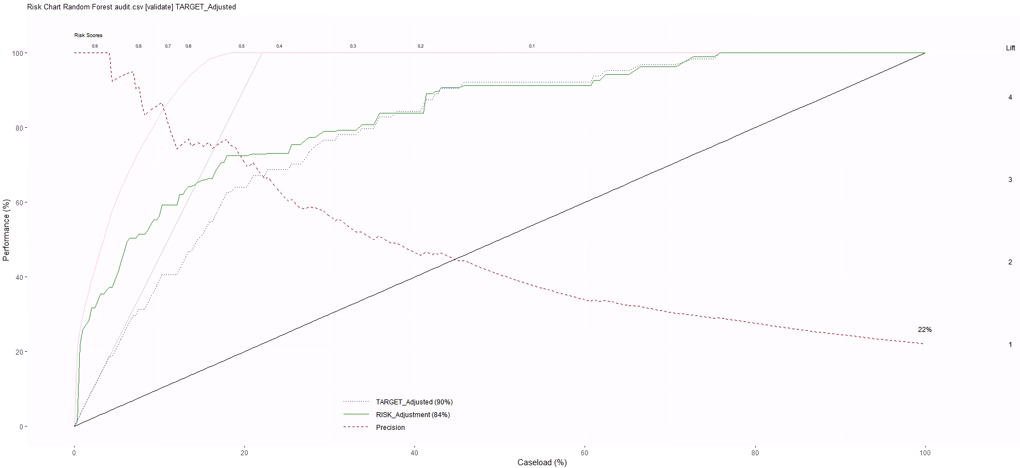
The four important lines in this risk chart are the increasing diagnonal line (baseline), the increasing dotted line (target adjusted), the increasing green line (risk adjusted), and the dashed decreasing line (precision). (Williams, 2011) The baseline, target adjusted, and risk adjusted lines show the proportion of required adjustments and the overall dollar amount that can be expected to be revealed based on the percentage of cases that are identified in a subset to investigate. For example, if an auditor had the resources to investigate 25% of the cases, the baseline shows that they can expect to uncover 25% of the returns that require adjustments as well as 25% of the total adjustments by dollar amount. However, if the auditor used to random forest model to select a specific 25%, they can then expect to uncover about 70% of the returns that require adjustments (dotted line) as well as 75% of the total adjustments by dollar amount (green line). The precision line shows that the random forest model performs about 3 times better than random selection at identifying the subset of 25%.
ROCR Charts
An ROC chart “plots the true positive rate against the false positive rate.” (Williams, 2011) A better performing model will be able to identify a higher rate of true positives without significantly increasing the rate of false positives. The performance can be summarized by the area under the curve. ROC lines closer to the top left, and farther from the baseline, will have a higher area under the curve and better performance. The random forest model on the audit data set can be compared to a basic decision tree and a support vector machine model according to their ROC charts. The ROC chart for the random forest model shows that in order to identify about 65% of true positives, it will only incorrectly classify about 10% of false positives. Additionally, it can identify 100% of the true positives at a cost of only about 75% of the flase positives. The total area under the curve for the random forest model is 0.89. For the decision tree it is 0.84 and for the support vector machine it is also 0.89. Looking deeper, although they have the same areas under the curve, the random forest performs better at a lower percentage of true positives and the support vector machine at a higher percentage of true positives.
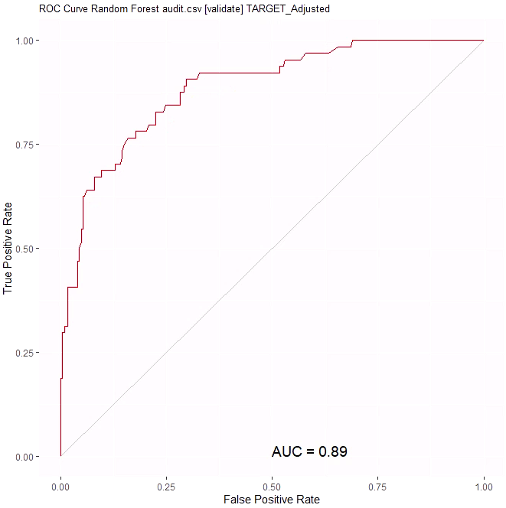
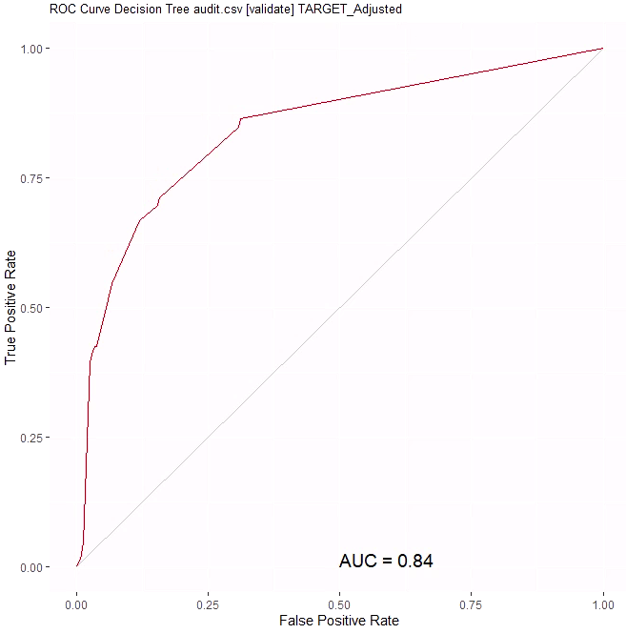

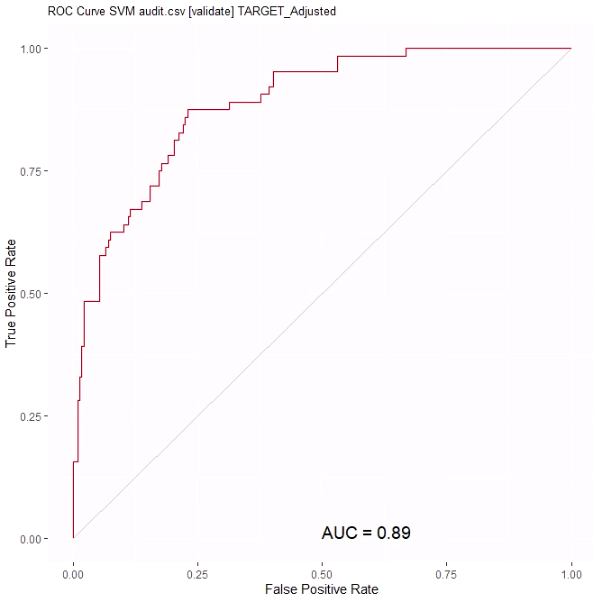
References:

Williams, Graham. 2011. Data Mining with Rattle and R : The Art of Excavating Data for Knowledge Discovery. Springer New York. Retrieved from http://ebookcentral.proquest.com/lib/snhu- ebooks/detail.action?docID=770229

